T**itle of the contribution**

Mallu M. Mainio1, Wille Wirtanen2 and Taisto Tutkija1,2

1 Coating Laboratory, Virtual University of City, The City  
2 Printing Department, University, The City

Corresponding author: mallu.mainio@unicity.wld

(Optional small paragraph with additional information concerning the authors may be added here, extending to several lines if needed)

The short abstract is limited to one single page. The authors are kindly asked not to change the style definitions in the template (in particular the use of 10pt Times New Roman). This helps the organizers to assemble the proceedings by using these similarly typesetted pages.

Consider providing a few introductory phrases to the subject for the the possibly unfamiliar reader. Of course you can cite references [1,2,3].

Then use the rest of the page to describe your objectives, methods and results (see also Fig. 1).

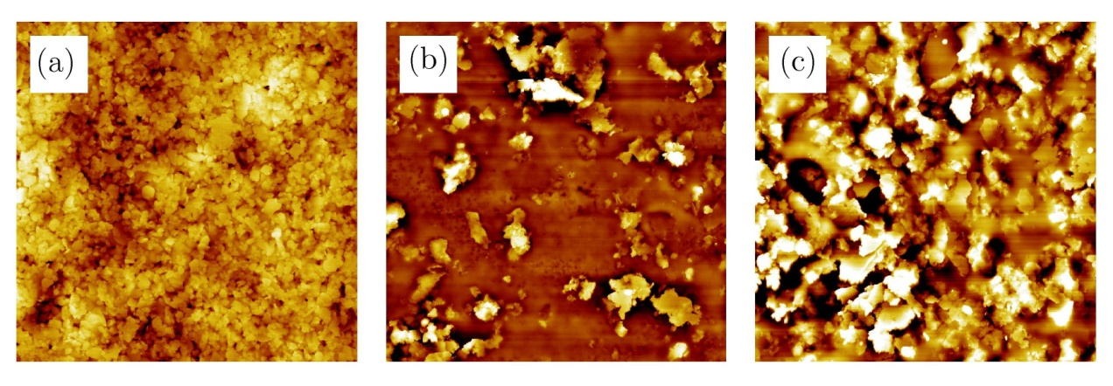

Fig. 1. We strongly encourage a figure/picture/illustration.

To summarize, the preferred way to construct the abstract is to

1. Start from the provided template in MS Word or LaTeX,  
2. Replace the text and other items with the real text/data,  
3. Generate a pdf-file,  
5. Submit it via the conference website at https://ecs2023.org/

**References**

1. M. Mainio, J. Juonio, and T. T. Tutkija, *Coating Journal* **12**, 123-129 (1998).

2. O.P. Guru and E. Stein, *The major source book of the subject,* (Publisher, Location, 1996).

3. More information can be found at: www.coatinglab.unicity/research/thesubject.html, valid 2/2002

4. A. Author, and C. Coauthor, [Optional: article title,] *Journal*, **volume**, pages (year).